Project Design Phase-II

Technology Stack

|  |  |
| --- | --- |
| Date | 14 October 2022 |
| Team ID | PNT2022TMID38796 |
| Project Name | Gas leakage monitoring and alerting system for industries |
| Maximum Marks | 4 Marks |

Technical Architecture:

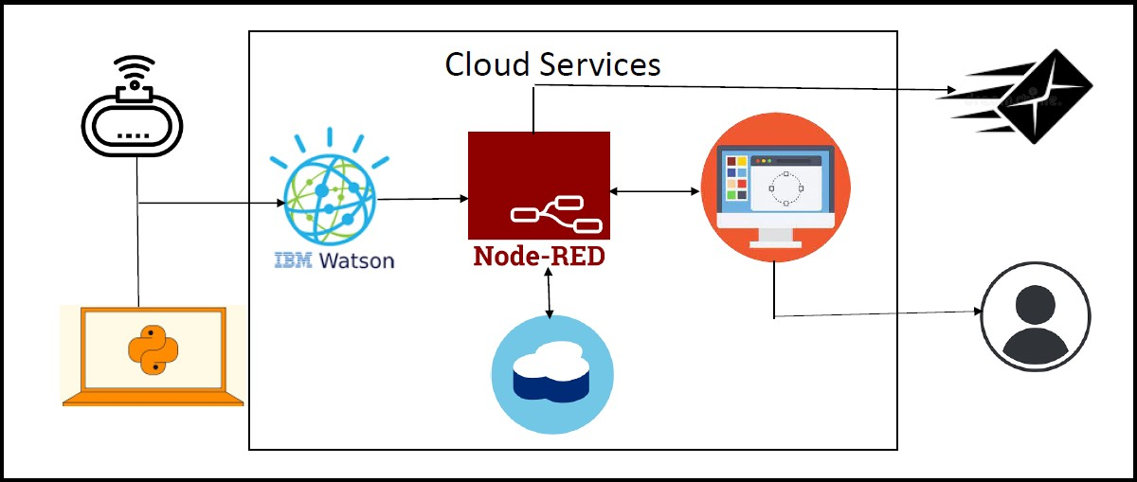

Table-1: Components & Technologies:

|  |  |  |  |
| --- | --- | --- | --- |
| **S.No** | **Component** | **Description** | **Technology** |
| 1. | User Interface | Web UI | HTML,CSS,Javascript |
| 2. | Application Logic-1 | Logic for a process in the application | Python |
| 3. | Application Logic-2 | Logic for a process in the application | IBM Watson STT service |
| 4. | Application Logic-3 | Logic for a process in the application | IBM Watson Assistant |
| 5. | Database | Data Type | MySQL, NoSQL, etc. |
| 6. | Cloud Database | Database Service on Cloud | IBM Cloudant. |
| 7. | File Storage | File storage requirements | IBM Block Storage |
| 8. | External API-1 | Purpose of External API used in the application | IBM Weather API |
| 9. | External API-2 | Purpose of External API used in the application | Aadhar API |
| 10. | Machine Learning Model | Purpose of Machine Learning Model | Object Recognition Model |
| 11. | Infrastructure (Server / Cloud) | Application Deployment on Local System / Cloud Local Server Configuration:  Cloud Server Configuration: | Cloud Foundry |

Table-2: Application Characteristics:

|  |  |  |  |
| --- | --- | --- | --- |
| **S.No** | **Characteristics** | **Description** | **Technology** |
| 1. | Open-Source Frameworks | The open-source frameworks used | Mozilla Firefox |
| 2. | Security Implementations | The security / access controls implemented, use of firewalls etc. | IBM cloud Encryptions |
| 3. | Scalable Architecture | The scalability of architecture (3 – tier, Micro- services) | IBM cloud architecture |
| 4. | Availability | The availability of application (e.g., use of load balancers, distributed servers etc.) | Web application can even be used by the workers in the industry |
| 5. | Performance | Consideration design for the performance of the application (number of requests per sec, use of  Cache, use of CDN’s) etc. | Since the web application is high efficient, it can be used by the workers  irrespective of time. |